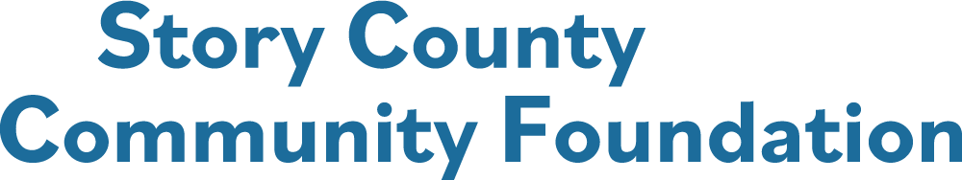

**FINAL GRANT REPORT**

**Reports are to be emailed to** [**ksevde@storycountyfoundation.org**](mailto:ksevde@storycountyfoundation.org)**.**

**Final Report Deadline is 5:00 PM, August 31, 2025.**

**All 2024 Grant Recipients are required to file a Final Report upon completion of the project and no later than end of day on August 31, 2025.**

**Name of Organization:**

**Contact Person for the application:**

**Title:**

**Person filing the Final Report, if different than the contact person:**

**Title:**

**Phone Number: Email:**

**Project Name:**

**Total Cost of the Project: $**

**Amount of Story County Community Foundation grant funds received: $**

**Matching Funds (if any): $**



**Project Review**

Summarize the goals of your project:

Were you able to attain these goals?

How did you evaluate the project? Please detail the program/project results.

If you modified the intended outcomes, indicate the changes. Were there unexpected successes/benefits?

Is the project complete? If it is on-going, is the project self – sustaining?

Please provide an expense report detailing how the SCCF grant money was spent. Include documentation of expenditures, such as receipts.

What type of recognition and publicity did the Story County Community Foundation receive for the grant funding?

Please include or share separately photos of the completed project( jpeg, png format).

Please submit your completed report, in one PDF packet to [ksevdey@storycountyfoundation.org](mailto:ksevdey@storycountyfoundation.org).

I certify the accuracy of the attached report for expenditure and usage of grant funds for the above-mentioned project and that the resulting balance is accurate.

**_____________________________________________________ _________________________________**

**Signature of Person Filing the Report Date**