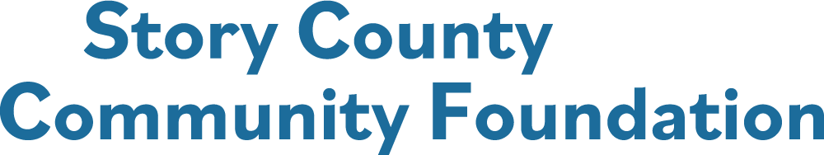

**McCallsburg Legacy Fund Grant Application**

**The deadline to submit the application in writing to the City Clerk, City of McCallsburg, Iowa**

**5:00 PM, March 28, 2025. The City Council will consider all applications during the April 2025 City Council meeting.**

**Name of Organization: EIN:**

**Contact Person for this application:**

**Title:**

**Address:**

**City: State: Zip Code:**

**Business Phone: Cell Phone of Contact:**

**Email Address: Website:**

**Organization’s Mission:**

**Number of Employees: Number of Volunteers:**

**The City of McCallsburg will be the Fiscal Sponsor for this grant. Funds will be directed to the City of McCallsburg and the City will distribute the funds to the grant recipient.**

**PROJECT OVERVIEW**

**Project Name:**

**Total Cost of the Project: $**

**\*Amount of Story County Community Foundation grant funds requested: $**

**\* Up to the McCallsburg Legacy Fund Spendable Balance determined on December 31st of the previous year.**



**Project Narrative**

**Describe the need or issue being addressed by this project and the population to be served:**

**Describe the project goals, objectives, and projected results:**

**Describe the steps you will follow to achieve the goals and objectives. Include a timeline of the projects:**

**Will this project have a long – term impact? How will this project be sustained?**

**Will you be collaborating with other community partners on this project? If yes, please include partner letters of commitment to this project:**



**Project Budget**

**Provide a budget for the project, with written quotes, bids, and other relevant information pertaining to the project’s budget. Do not include your organization’s budget for other projects or other operating expenses.**

**Matching funds, if applicable, are funds that will be contributed only if an equal amount of money is obtained from another source, such as the Story County Community Foundation.**

**Please be as specific as possible regarding how the Story County Community Foundation’s grant funds will be use, items to be purchased, etc.**

|  |  |  |  |  |
| --- | --- | --- | --- | --- |
| **Major Budget Items** | **Cost** | **In-Kind Funding**  **(name)** | **Matching Fund** | **SCCF Funding**  **Request** |
| **Example: wheelchair** | **$900** |  | **$300** | **$600** |
|  |  |  |  |  |
|  |  |  |  |  |
|  |  |  |  |  |
| **TOTAL** |  | **TOTAL** | |  |

**Funding Sources**

|  |
| --- |
| **Secured: Example: $300 match from XYZ Foundation** |
| **Applied for:** |
| **Other relevant information about potential funding sources:** |



**Application Check Sheet**

**Please submit your completed Community Grant Application through the online grant portal on the Story County Community Foundation website:** [**www.storycountyfoundation.org**](http://www.storycountyfoundation.org)**.**

**Remember to include and attach within the application:**

* **Please attach a list of your board of directors with their email addresses.**
* **Letters of commitment from partners collaborating on this project.**
* **Letters of support are not required but will be considered.**
* **Photos which may assist in the description of the project.**

**The organization’s representative for this project acknowledges and certifies that he/she is authorized to represent the organization and that the information contained in this application is accurate and correct.**

**If the grant is awarded to this organization for this project:**

* **The grant funds will be used for the purpose outlined in this application and grant award letter and may not be expended for any other purpose without consideration and written approval by the Story County Community Foundation.**
* **The Story County Community Foundation has received nothing of material value exchange for the grant funds.**
* **Projects are to be completed, and final report submitted on or before December 31st.**
* **Information about the organization and the grant award may be used by the Story County Community Foundation in any publication and social media sources.**
* **The organization agrees to reciprocate the announcement of the grant award, by publicizing the Story County Community Foundation and the grant award in the organization’s publications and social media outlets.**

**_____________________________________________________ _________________________________**

**Signature of Representative Date**