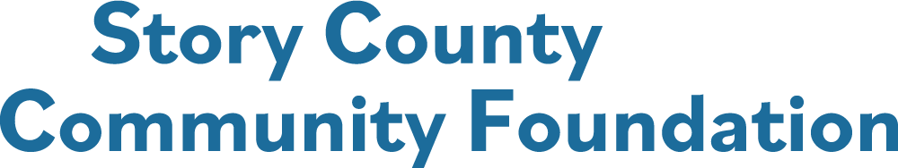

**ROGER BERGER GRANT FOR THE ARTS APPLICATION**

**Applications must be submitted through the online grants’ portal on our website.**

**Deadline to submit the application is 5:00 PM, September 30, 2025**

**Roger Berger was passionate about the arts, especially Opera. As part of his legacy, he established a fund to enhance the community’s access to Opera and other cultural programs. Per his direction, these are the criteria for this grant:**

1. **Applications must be submitted by at least two nonprofit, 501 (c) (3) organizations, collaborating on the project/programming to benefit all citizens in Story County.**
2. **The project/program must have a focus on community Arts and Culture, with a preference to promote and share Opera with the citizens of Story County. This may include live performances, educational sessions and other similar programming.**
3. **Applicants are encouraged to be creative, bold and innovative.**
4. **Projects/programs should provide a positive experience for all involved.**
5. **This may be a multi-year project/program, i.e.: establishing an annual Opera performance event for the community. We will consider funding for up to three (3) years, to establish the project/program.**



**Collaborating Organizations**

**Each Collaborating Organization must be listed and include the following information, along with submitting a copy of their respective current IRS Exemption Declaration Letter:**

**Contact Person for this application:**

**Title:**

**Address:**

**City: State: Zip Code:**

**Business Phone: Cell Phone of Contact:**

**Email Address: Website:**

**Organization’s Mission:**

**Number of Employees: Number of Volunteers:**

**Type of Organization:**

**501 (c) (3) Non – Profit Organization Federal Tax EIN* ____________________________________**

**\*You will be asked to submit a copy of the current IRS Exemption Declaration Letter.**



**PROJECT OVERVIEW**

**Project Name:**

**Total Cost of the Project: $**

**Will this be a multi-year project/program? If so, how many years? \***

**\*Funding may be requested for up to Three (3) years at $50,000 per year, for a total of $150,000 grant funding for the project.**

**Amount of Story County Community Foundation grant funds requested: $**

**Matching Funds (if any): $**

**Estimated number of Story County residents who will be impacted by this project:**

**Grant Recipients will submit a Final Report and Budget. If this is a multi-year project, grant recipients shall submit an annual report and budget to remain eligible for additional grant funding.**



**Project Narrative**

**Describe the need or issue being addressed by this project and the population to be served:**

**Describe the project goals, objectives, and projected results:**

**Describe the steps you will follow to achieve the goals and objectives. Include a timeline of the projects:**

**Describe the roles and responsibilities of each participating organization:**

**Will this project have a long – term impact? How will this project be sustained?**



**Project Budget**

**Provide a budget for the project, with written quotes, bids, and other relevant information pertaining to the project’s budget. Do not include your organization’s budget for other projects or other operating expenses.**

**Matching funds, if applicable, are funds that will be contributed only if an equal amount of money is obtained from another source, such as the Story County Community Foundation.**

**Please be as specific as possible regarding how the Story County Community Foundation’s grant funds will be used, items to be purchased, etc.**

|  |  |  |  |  |
| --- | --- | --- | --- | --- |
| **Major Budget Items** | **Cost** | **In-Kind Funding**  **(name)** | **Matching Fund** | **SCCF Funding**  **Request** |
| **Example: wheelchair** | **$900** |  | **$300** | **$600** |
|  |  |  |  |  |
|  |  |  |  |  |
|  |  |  |  |  |
| **TOTAL** |  | **TOTAL** | |  |

**Funding Sources**

|  |
| --- |
| **Secured: Example: $300 match from XYZ Foundation** |
| **Applied for:** |
| **Other relevant information about potential funding sources:** |



**Application Check Sheet**

**Please submit your completed Grant Application through the online grant portal on the Story County Community Foundation website:** [**www.storycountyfoundation.org**](http://www.storycountyfoundation.org)**.**

**Remember to include and attach within the application:**

* **A copy of the current IRS Declaration Letter for 501 (c) (3) status, or that of the fiscal sponsor with documentation of status as a charitable project of a government agency for all cooperating applicants.**
* **Please attach a list of your board of directors with their email addresses.**
* **Letters of commitment from partners collaborating on this project.**
* **Letters of support are not required but will be considered.**
* **Photos which may assist in the description of the project.**

**The organization’s representatives for this project acknowledge and certifies that he/she is authorized to represent the organization and that the information contained in this application is accurate and correct.**

**If the grant is awarded to this organization for this project:**

* **The grant funds will be used for the purpose outlined in this application and grant award letter and may not be expended for any other purpose without consideration and written approval by the Story County Community Foundation.**
* **The Story County Community Foundation has received nothing of material value in exchange for the grant funds.**
* **Projects are to be completed, and final report submitted by October 31st of the following year.**
* **Information about the organization and the grant award may be used by the Story County Community Foundation in any publication and social media sources.**
* **The organization agrees to reciprocate the announcement of the grant award, by publicizing the Story County Community Foundation and the grant award in the organization’s publications and social media outlets.**

**_____________________________________________________**

**_____________________________________________________ _________________________________**

**Signatures of Representatives Date**