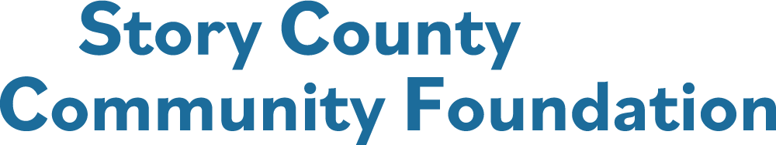

COMMUNITY GRANT APPLICATION
Applications must be submitted through the online grants’ portal on our website.
Deadline to submit the application is 5:00 PM, September 30, 2026

Name of Organization:
Contact Person for this application:
Title:
Address:
City: State: Zip Code:
Business Phone: Cell Phone of Contact:
Email Address: Website:

Number of Employees: Number of Volunteers:
Type of Organization:
501 (c) (3) Non – Profit Organization Federal Tax EIN* ____________________________________
*You will be asked to submit a copy of the current IRS Exemption Declaration Letter

170 (c) (1) Local Government Agency Federal EIN* _____________________________________
*If your agency does not have the required IRS status, you will need a fiscal sponsor.
Name of Fiscal Sponsor if different than applying agency:
Fiscal Sponsor EIN:
Fiscal Sponsor Address:
City: State: Zip Code:
Fiscal Sponsor Phone Number: Website:

PROJECT NARRATIVE
Community Grant Requests of up to $25,000 will be considered.

Project Name:

Briefly describe the need, challenge, or opportunity this project addresses. Include relevant context and data and clearly identify the population(s) served. [25 points]
Outline the project’s overall goal(s) and list specific, measurable objectives, including the outcomes you expect to achieve. [20 points]

Describe the key activities and steps required to achieve the stated goals and objectives. Provide a reasonable timeline for implementation. [15 points]

Explain the long-term impact this project is expected to have. If applicable, describe how the project will continue or be sustained after grant funds are exhausted. [10 points]

Explain how you will publicly recognize the Story County Community Foundation for its grant support. Include specific communication methods (e.g. print, digital, or in-person), target audiences and opportunities for public recognition or visibility. [5 points]

Project Budget & Financial Overview

Provide a detailed project budget that outlines all anticipated revenues and expenses. [10 points]
- Amount requested from the Story County Community Foundation
- Additional funding sources, secured and/or pending: e.g. have you applied for grant funding for the same project with another source? If so, who with?
- List of all in-kind contributions
Provide a line-item budget for all planned expenditures. Upload quotes of items to be purchased, bids for contract work to be done and all relevant information we may need to consider your request. [10 points]

Major Budget Items | Cost | In-Kind Funding  (name) | Matching Fund | SCCF Funding  Request
Example: wheelchair | $900 |  | $300 | $600
TOTAL |  | TOTAL

Explain how the Story County Community Foundation grant funds will be used. Will the funds pay for the entire project? If not, what items will the funds be used for? [5 points]
Have you applied for grant funding from another source for the same project? Please notify us if this project receives additional funding from another source after you submit this application.
Have you previously received a grant from the Story County Community Foundation? If so, please list the year, amount and project.

Application Check Sheet

Please submit your completed Community Grant Application through the online grant portal on the Story County Community Foundation website: www.storycountyfoundation.org.
Remember to include and attach within the application:
- A copy of your current IRS Declaration Letter for 501 (c) (3) status, or that of the fiscal sponsor with documentation of status as a charitable project of a government agency.
- Please attach a list of your board of directors with their email addresses.
- Letters of commitment from partners collaborating on this project.
- Letters of support are not required but are appreciated and will be considered.
- Photos which may assist in the description of the project.
The organization’s representative for this project acknowledges and certifies that he/she is authorized to represent the organization and that the information contained in this application is accurate and correct.
If the grant is awarded to this organization for this project:
- The grant funds will be used for the purpose outlined in this application and grant award letter and may not be expended for any other purpose without consideration and written approval by the Story County Community Foundation.
- The Story County Community Foundation has received nothing of material value in exchange for the grant funds.
- Projects are to be completed, and final report submitted on or before August 31, 2027.
- Information about the organization and the grant award may be used by the Story County Community Foundation in any publication and social media sources.
- The organization agrees to reciprocate the announcement of the grant award, by publicizing the Story County Community Foundation and the grant award in the organization’s publications and social media outlets.

__________________________________________________________________________________________
Signature of Representative Date

